**Laboratory Experiment 3: Position Control Experiment**

MTRN3020 Modelling and Control of Mechatronic Systems

I verify that the contents of this report are my own work.

Evan Darmanin

z3251862

2nd October 2012

Contents

1. Introduction 2

2. Aim 2

3. Procedure 3

4. Controller Design 4

5. Simulink Block Diagram of the Experiment 7

6. Part A – Verifying design with correct plant 8

7.1 Part B – Modelling Uncertainties 9

7.2 Part B – Verifying design with incorrect plant 10

8. Conclusion 11

# Introduction

This experiment refers to the design and implementation of a speed and position controller of a motor and gear box to move an armature to variable locations. This experiment is about providing students with an experience in designing a controller from a set of design specifications. The experiment involves predicting controller performance and comparing to actual results obtained through implementation of the designed controller to give students feedback on how successfully their controllers performed.

# Aim

The aim of this experiment is to verify whether a designed controller functions correctly in reality compared to expected performance.

# Procedure

The experiment involved students inputting controller parameters into a computer and instructing the computer to run the motor controller to drive the armature. The armature was required to rotate to specific angular positions. This was verified by two stages of testing, one under conditions of a correctly weighted armature and a second test where the inertial characteristics of the armature were unexpected.

This experiment required students to first prepare calculations using the direct analytical design method given certain design specifications. For this particular experiment the specifications were a sampling time of 5ms and a design Tau value of 32ms.

When calculations had been made the student input their unique values into the computer and began the first testing stage where the test rig was required to rotate and stop at 5 predetermined positions, one every two seconds. The armature of the rig was set to a length of 225mm, the length at which calculations had been based on. The second stage saw the length of the armature increased to 445mm and the 5 position test was repeated.

The armature’s angular position was measured and recorded for the duration of the test. The output of the computer was made available for analysis of the performance of the controller.

# Controller Design

The unique design tau time is 32ms. The sample time is 5ms.

Using the MATLAB function to do curve fit:

x = lsqcurvefit(@myfun,[280000,1],t,s)

I obtained the following A and Tau values:

A = 281000;

tau = 0.0627;

Hence the calculations are as follows:

$$A=281000$$

$$G'p\left(s\right)= \frac{281000/24}{s(1+0.0627s)}$$

Relating the input voltage to the input shaft speed in rad/s is,

$$Gp\left(s\right)= \frac{8.9802}{s(1+0.0627s)}$$

Using the MATLAB functions:

num = [8.9802];

den = [tau 1 0];

[gpnumd, gpdend] = c2dm(num,den,sampleT,’zoh’);

The roots of gpnumd yield the numerator values of A(z) and similarly the roots of gpdend are the values for the denominator of A(z).

The value C is found using gpnumd(2).

Hence:

$$A\left(z\right)= \frac{0.00173(z+0.9738)}{(z-1)(z-0.9234)}$$

Gp(z) can be found straightforwardly since:

$$Gp(z)= A\left(z\right)\frac{(z-1)}{zT}$$

$$Gp(z)= \frac{0.3455(z+0.9738)}{(z)(z-0.9234)}$$

To form F(z) we use:

$$F(z)=\frac{bo (z-z1)}{z(z-e^{T/Td})}$$

Due to the ringing effect caused by the zero of the numerator of Gp(z).

Subbing in:

$$F(z)=\frac{bo (z+0.9738)}{z(z-0.8553)}$$

If we substitute F(1) = 1 we can find *bo:*

$$bo=\frac{ 1(0.1447)}{(1.9738)}=0.0733$$

$$F(z)=\frac{0.0733 (z+0.9738)}{z(z-0.8553)}$$

We can now find Gc(z):

$$Gc(z)=\frac{1}{Gp\left(z\right)}\frac{F(z)}{(1-F\left(z\right))}$$

$$Gc(z)=\frac{ 0.005}{0.3455}\frac{ (z)}{(z)}\frac{ (z-0.9234)}{(z-0.8553)}\frac{ (z+0.9738)}{(z+0.9738)}\frac{ (0.0733)(z)(z-0.8553)}{z\left(z-0.8553\right)- 0.0733(z+0.9738)}$$

$$Gc(z)=\frac{ 0.2121z^{2}-0.1959z}{z^{2}-0.9286z-0.0714}$$

where the roots of the numerator are 0 and 0.9234.

The roots of the denominator are 1.000 and -0.0714

The controller then can be written with the difference equation:

$$m\left(k\right)= 0.9286m\left(k-1\right)- 0.0714 m\left(k-2\right)+ 0.2121e\left(k\right) -0.1959 e(k-1)$$

The position controller can be found by combining the entire velocity loop, the integrator and the 2K gain and the gear ratio of 1/38.4.

$$G\left(z\right)=2K.\frac{1}{38.4}.\frac{\left(z\right)(0.005)(z+0.9738)}{(z)(z-0.8553)}$$

$$G\left(z\right)=\frac{(1.909 ×{10}^{-5})(z+0.9738)}{z^{2}-1.8553z-0.8553}$$

Taking this into MATLAB:

Gz = tf(1.909*10^-5*[1 0.9738], [1 -1.8553 0.8553])

rlocus(Gz)

Yields the following diagram (fig. 1):

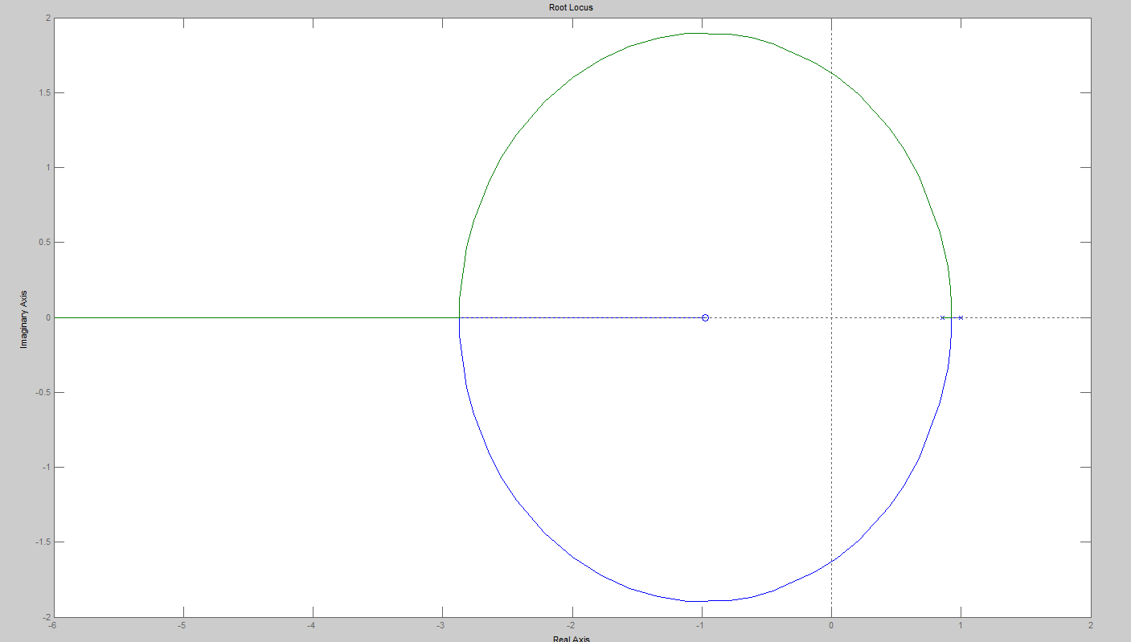

Figure 1 – Root locus of G(z)

Inquiring at the break-away point allows us to find:

5. Simulink Block Diagram of the Experiment

This diagram below (fig.2) shows the experiment as simulated using Simulink.

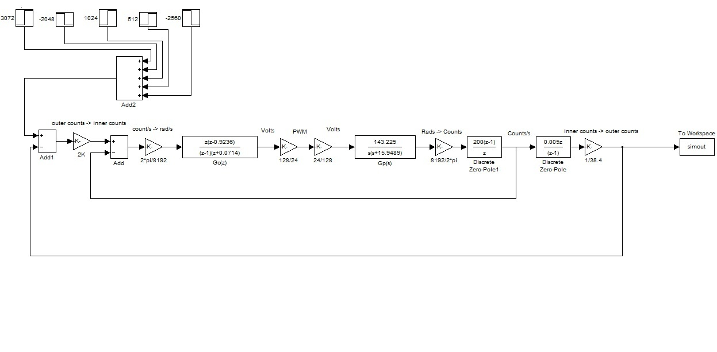

Fig. 2

* Correct plant block diagram

# **6. Part A – Verifying design with correct plant**

The following plot (fig. 3) is the output of the block diagram from figure 2 overlayed onto experimental data. It shows the correlation between the experimental data and the predicted data from the modelling of the position controller.

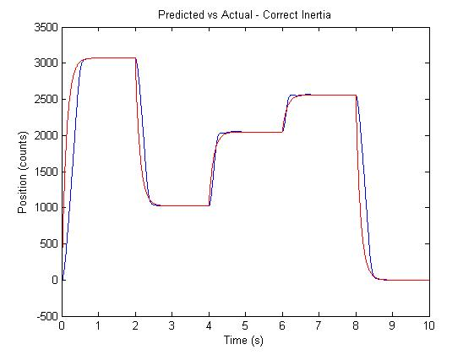

Fig.3 - Performance Graph

Experimental vs. predicted data

This plot shows that the design is correct, the experimental results (blue) matches the predicted results (red) reasonably well. There is some rise time discrepancy, however the desired position is achieved and there is no overshoot.

The discrepancy in the rise time can be attributed to saturation in the control effort. The power source cannot deliver infinite voltage to accelerate the motor and hence the motor can only accelerate so fast. When comparing the predicted to actual results we notice that the predicted acceleration exceeds what is actually possible and thus explains the delay in rise time.

We notice however that when the control effort is not saturated the experimental vs. predicted data matches the desired position very accurately and hence shows that the design is correct.

# **7.1 Part B – Modelling Uncertainties**

The plant calculations for the 445mm armature are as follows.

Using the MATLAB function to do curve fit:

x = lsqcurvefit(@myfun,[280000,1],t445,s445)

I obtained the following A and Tau values:

A = 279195;

tau = 0.1111;

Hence the calculations are as follows:

$$A=279195$$

$$G'p\left(s\right)= \frac{279195/24}{s(1+0.1111s)}$$

Relating the input voltage to the input shaft speed in rad/s is,

$$Gp\left(s\right)= \frac{8.9225}{s(1+0.1111s)}$$

Using this plant we can obtain the following block diagram:

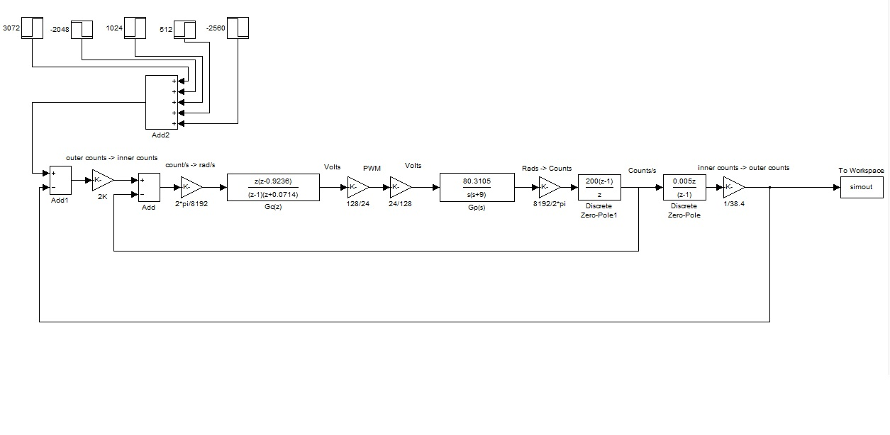

Fig. 4

* Plant block diagram with incorrect inertia

The only difference between fig. 4 and fig. 2 is the change of the plant Gp(s).

# **7.2 Part B – Verifying design with incorrect plant**

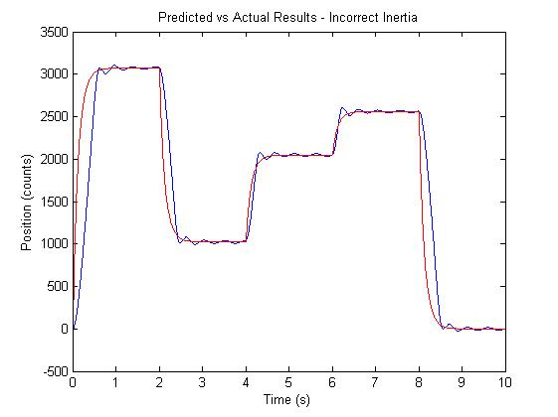The following plot (fig. 5) is the output of the block diagram from figure 4 overlayed onto experimental data. It shows the correlation between the experimental data and the predicted data from the modelling of the position controller.

Fig.5 - Performance Graph

Experimental vs. predicted data

This plot shows that the design is not perfectly correct. The experimental results (blue) loosely follow the predicted results (red) with the following exception. There is some rise time discrepancy as before, however there is also some overshoot and oscillation in final position.

The experimental results show that the increased inertia of the 445mm

armature caused the rig to overshoot its desired position, a factor not present in the design with the correct transfer function. This can be attributed to the difference in inertia between the two rigs where the expected time and energy needed to slow the 445mm rig was insufficient to stop the arm on its mark. This occurred at a decreasing rate due to the control effort’s insufficient power to significantly overshoot the desired position.

Similar to fig. 3 this performance graph shows that the rise time of the predicted and actual results do not match, and can be attributed to saturation in the control effort. One can deduce that the simulink model predicts that the controller should be able to handle the design uncertainties, however due to saturation of the motor impulse the changes in inertial properties of the armature cannot be handled in reality.

# 8. Conclusion

One will notice from Figure 3 and Figure 5 that the predicted and experimental plots do not match up exactly, rather there is some error in the periods of sudden position change. As discussed this can be attributed to saturation in the control effort due to a maximum achievable voltage to accelerate the motor that is not accounted for in the Simulink model.

The key discrepancies to note in figure 5 are the oscillations about the desired position that are not predicted by the model. These can be attributed to the increased inertia of the armature (and hence different transfer function in the plant) that causes the control effort to be insufficient to slow down the armature at the correct position.

On the other hand the experiment does observe stability in both tests at positions close to the desired position. Depending on the application one could consider both experiments successful as they achieve their goal of reaching a desired position, albeit the second test taking a few seconds to dampen oscillations. Similarly the discrepancies in rise time are relatively small, and despite the differences in the predicted vs. actual performance in reality the armature reaches the desired position very quickly.

In essence the controller is valid in terms of its ability to maintain accurate control – the armature does reach the position it was intended to. The controller’s performance in the experiment is slower and more unstable than predicted in the simulation and this can be attributed mainly to saturation in the control effort.

Other errors that may have contributed to the difference between expected and actual results includes variability in plant parameters. Armature inertia, motor inertia, armature length and air resistances are areas of potential error and may have been different during the test compared to what is predicted. Any errors of this nature would change the plant transfer function slightly and contribute to a difference between expected and measured results.

The location of the armature was measured with a ruler and shifted by hand is a potential source of human error effecting plant characteristics. The test bench is assumed to be completely stationary however may shake slightly during testing, which is not accounted for in the model.